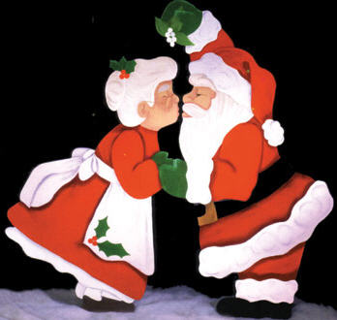

Merry Christmas "Name of Person"

It's Christmas morning. And, of course, Santa has been here. One by one, you will receive the chance to find your gifts. You will share the morning with family, dear. You will smile and laugh and perhaps share your cheer. But let's not forget the purpose for which we gather, the birth of Christ's child. As you search for your gifts, try to remember the most important gift of all. The gift of our Lord, the Christ, our redeemer, our brother, has shown us how to be happy and share his joy.

It's now time to start your Christmas Cheer.

Christmas 1

Christmas Fact:
Hanging the Christmas stocking on the hearth on Christmas Eve in the hope that it will be filled with presents the following day is a custom that goes back about 400 years. It derived from the custom in Holland of children placing wooden shoes next to the hearth the night before the arrival of St. Nicholas. The children would fill their shoes with straw and food for St Nicholas's for the donkey that carried the gifts. In exchange, he would leave them a small gifts such as small cakes, fruits and other gifts. Stockings were substituted for the shoes in Britain, most of Europe and North America.

Christmas Riddle:
Why was Santa's little helper depressed?
Because he had low elf esteem.

I'm a rock. I'm wood. I'm fast. Clear the rack. Fill my pockets. But don't worry about the eight unless you are prepared to win a game. Look to the top, and there you will find your present.
Pool Table

Christmas 2

Christmas Fact:
Mexicans call the poinsettia "Flower of the Holy Night" - the Holy Night is the Mexican way of saying "Christmas Eve."

Why does Scrooge love Rudolph the Red-Nosed Reindeer?
Because every buck is dear to him.

Twenty-two players line the field. With a spin and turn, we kick the ball. Kick a goal and earn the point under the field of blue. Where would you find your gift?
Under the foosball

Christmas 3

Christmas Fact:
St. Nicholas was the bishop of the Turkish town of Myra in the early fourth century. The Dutch first made him into a Christmas gift-giver, and Dutch settlers brought him to America, where his name eventually became the familiar Santa Claus.

What do you call Santa when he has no money?
Saint Nickel-less

Costco, Costco, that's where mom goes. She fills the cart, brings it home, and stores it throughout the home. But when it's cold and thawing fast, you know she will freeze it. Now, where could that be? Come and see. But be forewarned, it's cold out here. Look to my top, and will share a gift with you.
On Freezer

Christmas 3

Christmas Fact
On Christmas morning since medieval times, church bells have been rung to announce to the world the coming of the Saviour. It was customary from the 18th century to wear clothes and carry a small bell to signify the birth of Christ, and the ringing of the bells was to signify the importance of the His Birth.

What do you get if you cross an apple with a Christmas Tree?
A pineapple

Oh, Christmas tree, O Christmas tree, A silent night, and jingle bells. Practice, practice, practice, for Christmas Eve. When I'm in tune, I'm as good as the hands before me but always desire to sound better. Come and stand before me and look to my feet. I will have the present you seek.
By Piano

