Merry Christmas "Name of Person"
From Santa

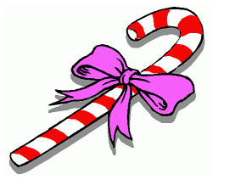

It's time to start your Christmas adventure. Solve each problem. Then search out and find one gift at a time. Once you have found your present, return to let the next person in line begin their quest. Don't worry; you will have four chances to find your Christmas Treasure.

Christmas 1
Which of these events did NOT occur on Christmas Day?
a. Hong Kong fell to the Japanese in WWII.
b. Ebenezer Scrooge was visited by four ghosts.
c. King Arthur pulled Excalibur from the stone.
d. Charlemagne was crowned Holy Roman Emperor.

HO HO HO HO……Which one is the answer?
If answer a: Your present is on your chair in
kitchen.
If answer b: Your present is on the Video Closet.
If answer c: Your present is on the third bookshelf
behind the world atlas.
If answer d: Your present is in Santa's shower.

Christmas 2
What two letters are used by the elves to describe
Santa's bag the day after Christmas?
M T (empty)

What part of Santa's Sleigh is empty the morning after he is through delivering toys to all the little boys and girls.
Back of Santa's Truck

Christmas 3
What's the difference between snowmen and snowwomen?
Snowballs.
Find the Snowman and Snow Woman. Look behind there you will find your present.
On the Shelf in the family room by the snowman and snowwoman decoration

Christmas 4

What bites but has no teeth?
Frost

Being outside without a coat is a little Coo Coo. Go to the Coo Coo and look below. There you will find your present.
Under the CoCo Clock

