Merry Christmas "Name of Person"
From Santa

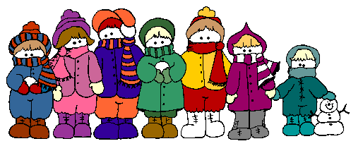

It's time to start your Christmas adventure. Solve each problem. Then search out and find one gift at a time. Once you have found your present, return to begin and solve your next quest. Doesn't worry; you will have four chances to find your Christmas Treasure.

Christmas 1

Santa's only female sleigh-pulling reindeer, Vixen, has antlers. True or false?
a. False. Only the male reindeer have antlers.
b. True. Both male and female reindeer have antlers.
c. True. But they are no bigger than slight bumps on their heads.
d. False. Some females have been known to have antlers, but that is extremely rare.

HO HO HO HO……Which one is the answer?
If answer a: Your present is on your chair in
kitchen.
If answer b: Your present is on Mrs. Clauses' sleigh
seat.
If answer c: Your present is next to the folded
bathroom towels.
If answer d: Your present is behind the Rotating
Christmas Tree.

Christmas 2

Why is a stick of Christmas candy like a horse?
The more you lick it, the faster it goes.

Quick, Quick, Quick, go to the place where you be wet and then dry simply by going round and round like a horse on the Merry-go-round.
Dryer

Christmas 3
What is filled every morning
and emptied every night,
except at Christmas
when it is filled in the night and
emptied in the morning?
Your stockings

When your socks are dirty, there is only one thing to do: clean them. Go there, and you will find your present.
Washer

Christmas 4

Knock Knock.
Who's there?
Holly.
Holly who?
Holly up and open this door-- It's freezing out here!

How long are you going to wait? It's freezing in here. Open the door and find your present.

Freezer

Christmas 5

What comes after '8 maids a-milking in the song 'The 12 Days of Christmas'?
a. 9 pipers piping
b. 9 lords a-leaping
c. 9 drummers drumming
d. 9 ladies dancing

HO HO HO HO……Which one is the answer?

If answer a: Your present is the fridge, third
shelf from the top.
If answer b: Your present is on the third chair
from the right of the dining room table.

If answer c: Your present is under Santa's bed
If answer d: You're present under the seat of
Santa's Red Sleigh.

Christmas 6

As you were going to the North Pole
You met nine elves coming;
Each elf had nine reindeer,
Each reindeer had nine bags,
Each bag had nine puppies,
And each bag also had nine cats,
Reindeers, elves, puppies and cats,
How many were going to the North Pole?
Only you. The elves were going in the opposite direction.

Need help in finding the present? Ask the bear.

The present is by the Winnie the Pooh Bear Decoration

