Merry Christmas "Name of Person"
From Santa

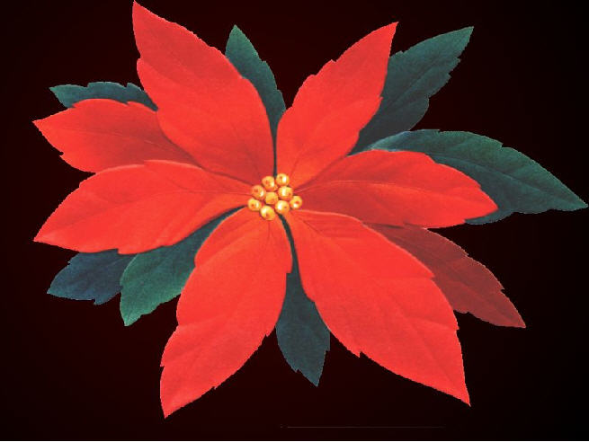

It's time to start your Christmas adventure. Solve each problem. Then search out and find one gift at a time. Once you have found your present, return to let the next person in line begin their quest. Don't worry; you will have four chances to find your Christmas Treasure.

Christmas 1

How many reindeer does Santa Claus have?
a. Santa has eight reindeer.
b. Santa has nine reindeer.
c. Santa does not have reindeer, and they are caribou.
d. Santa has a whole herd of reindeer-- we only know about his favorite ones.

HO HO HO HO……Which one is the answer?
If answer a: Your present is on the third chair
from the left of the dining room
table.
If answer b: Your present is under the pool table.
If answer c: Your present is under mom and Santa's
bed
If answer d: You're present in the left-hand saddle
back of Santa's bike.

Christmas 2

Two brothers we are,
Belonging to Santa,
Great burdens we bear
By which we are bitterly pressed;
The truth is to say
We are full all the day
And empty when we go to rest.
What can we be?
Santa's boots.

Find the place of Santa's twins, and you will find your present.
Santa's boots.
____
Christmas 3
Why did the Christmas cookie go to the doctor?
It was feeling crummy!

So tell me, where do you find cookies? Go there, and you will find your present.
Cookie jar

Christmas 4
If Santa and a polar bear were to scratch a piece of foam, who would scratch it harder, Santa or the polar bear?
Santa, because he has Claus (claws) and the
bear has paws.

If Santa was to come to our house and you wanted home to sit next to you at the table, where would he sit? Go there, and you will find your present.
In-chair next to the child

