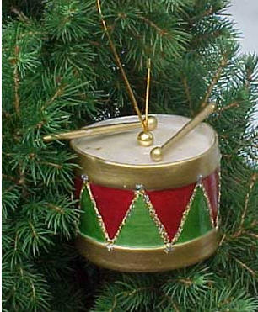

Merry Christmas “Nam of Person”

It’s time to start your Christmas adventure. Solve one riddle at a time. Search out and find one gift at a time. Once you have found your present, return to let the next person in line begin their quest. Don’t worry; you will have three chances to find your Christmas Treasure.

Christmas 1

Why did the Christmas cookie go to the doctor?
He felt crummy.

A sweet treat, perhaps a chip, at least dozen cans and don’t forget the cider and chocolate too. Come in and select your pleasure and don’t forget to choose your present.
Pantry

Christmas 2

What is filled every morning and emptied every night,
except at Christmas when it is filled in the night and
emptied in the morning?
Santa’s Boots

Three lights of red which are not lit stand in place of roses red. Check beneath the green leaf foliage to find the gift of Christmas.
Beneath the coffee table

Christmas 3

A very small girl with very short legs got so excited at seeing Santa Clause on the street corner that she jumped across the street. How did she do it?
She crossed the street and then jumped

Oh Christmas tree, O Christmas tree, A silent night, and jingle bells. Practice, practice, practice, for Christmas Eve. When I’m in tune, I’m as good as the hands before me, but always desire to sound better. Come and stand before me and look to my feet I will have the present you seek.
Piano

