Merry Christmas "Name of Person"
From Santa

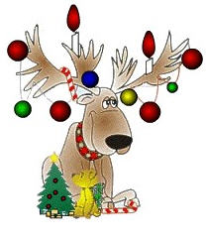

It's time to start your Christmas adventure. Solve each problem. Then search out and find one gift at a time. Once you have found your present, return to let the next person in line begin their quest. Don't worry; you will have four chances to find your Christmas Treasure.

Christmas 1

Santa's only female sleigh-pulling reindeer, Vixen, has antlers. True or false?
a. False. Only the male reindeer have antlers.
b. True. Both male and female reindeer have antlers.
c. True. But they are no bigger than slight bumps on their heads.
d. False. Some females have been known to have antlers, but that is extremely rare.

HO HO HO HO……Which one is the answer?
If answer a: Your present is on your chair in
kitchen.
If answer b: Your present is on Mrs. Clauses' sleigh
seat.
If answer c: Your present is next to the folded
bathroom towels.
If answer d: Your present is behind the Rotating
Christmas Tree.

Christmas 2

Why is a stick of Christmas candy like a horse?
The more you lick it, the faster it goes.

Quick, Quick, Quick, go to the place where you be wet and then dry simply by going round and round like a horse on the Merry-go-round.
Dryer

Christmas 3
What is filled every morning and emptied every night,
except at Christmas when it is filled in the night and
emptied in the morning?
Your stockings

When your socks are dirty, there is only one thing to do: clean them. Go there, and you will find your present.
Washer

Christmas 4

Knock Knock.
Who's there?
Holly.
Holly who?
Holly up and open this door-- It's freezing out here!

How long are you going to wait? It's freezing in here open the door and find your present.
Freezer

